Apollo Root List:  duct= lead  fess= to speak  mech= machine  meter=measure  -ous=possessing the qualities  out= exceeds  photo=light  port=carry  semi=half  tri=three | Athena Root List:  -able=can be done  aqua=water  aud(i)=hear  -ful=full of something  -ible=can be done  in-=not  ist-=one who  multi-=many  ped=foot/feet  uni-=one | Helios Root List:  co-/com- = together/with  con = with  de- = down/ off of  extra- = outside/beyond  inter- = between/among  non- = not  phon(o) = sound  sphere = ball  tele = far away  vis = see | Hercules Root List:  chron(o) = time  cred = believe  dia- = through/across  dict = say/speak  ex- = out  hyper- = too much  hypo- = under  hydr(o) = water  pop = people  proto- = first | Iris Root List:  bibli(o) = book  contra = against  graph=write/draw  -ive =tendency towards  fract = break  micro = little  macro = big  psych = mind/soul  therm = heat  -tion = action or process
Nemesis Root List:  arch- = most  auto = self  equ(i) = equal  geo = earth  ject = throw  -ology = study of  mon(o) = one, alone  struc(t) = build  trans- = across/change  voc = voice | Nike Root List:  a-=not  anti-=against  bi-=two  bio= life  cent=one hundred  -less=without  post-=after  pre-=before  sub-=under  un-=not | Olympians Root List:  anthro- = human being  astr(o) = star  dur = hard/lasting  fig = form  grad= step  meta- = change  mot = move  para- = aside/apart  rid = laugh  vac- = empty | Poseidon Root List:  bene- = good  dis- = not or away  -er = more or one who does  -est = most  -ly = in a way that is  mis- = badly or wrongly  -ness = state of  -or = person who  re- = again  spec = to see or look | Zeus Root List:  carn = flesh  grat = pleasing  later = side  morph = shape  myth- fiction  onmi- = all  - phobia = fear of  quin(t) = five  terra = land  vor = eat
Latin Root Word Sets
HOMEWORK: A 2-week study for each new set
Week 2: Latin/Greek Root Set Handout OR
4 Online activities at www.mrsmondragon.weebly.com
Click on Resources, Language Support, #7 for Latin/Greek Practice for Olympian Set
Week 1: Cornell Notes Directions:
- Root Word | A: Definition/meaning  B. Root =Meaning  Root =Meaning  Root =Meaning  Root =Meaning  Root =Meaning  C. Write 2 English words with root  D. Choose 1 English word with root  and write it in a sentence.
1. duct  SAMPLE | A. Lead  B. duct=lead  duct=lead  duct=lead  duct=lead  duct=lead  C. aqueduct, abduct  D. The great and highly advanced Roman waterway system known as the Aqueducts, are among the greatest achievements in the ancient world.
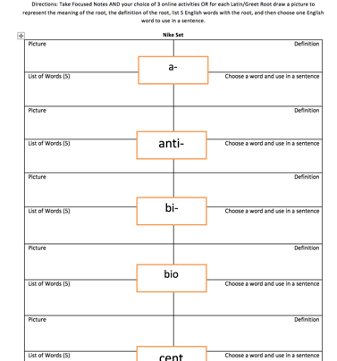
This

That
OR

