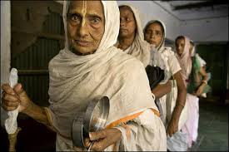
Name __________________
Date___________________
Period_________________

Widows of India Reflection
3,2,1 Video Notes
3 Observations/Annotations | 2 Connections | 1 Question

1. After watching the video on widows of India answer the following questions (You can always watch the video again by going to my website at www.mrsmondragon.weebly.com, click on Handouts, scroll down to video.)
What were your initial thoughts about the way women are treated in India when their husbands die? How would you feel if your mother was a widow or If you were a widow and you lived in a community that practiced this treatment of widows? This practice of shunning widows is rooted in their conservative religious beliefs of Hinduism. Do you think it is right for the women to be treated like this if is part of their religious beliefs? Who is to say whether a practice is just and right if it stems from religious beliefs? Why is it important to understand religious beliefs? If one felt passionate about making change in India regarding the treatment of widows, how could someone make the changes? Give examples.

